BST at drupa 2024: Hall 10, Stand C21
BST presents quality and efficiency-enhancing innovations for the sustainable optimization of printing processes
Bielefeld, March 2024: BST, the specialist for quality assurance systems for web converting processes, is unleashing a veritable firework display of innovations at drupa to help manufacturers make their production processes more efficient, sustainable and reliable. In line with the BST campaign 'FOR YOU', the focus of all innovations is on the user, who benefits in two ways: streamlined, intuitive operation and perfect print results with minimal waste. This is made possible by the digitally networkable, quality-enhancing web guiding and register control, web monitoring and inspection systems from BST, which will be on display at the BST stand 10 C21. With new, enhanced functions, they enable performance that far exceeds industry-defined standards. Visitors can also get to know the numerous advantages of SMARTData, which can be used to centrally operate, control, analyze, optimize and document production processes, and is unique in the industry in terms of its possible complexity.
SMARTData - BST presents market-ready software
With SMARTData, BST provides the solution to the cross-industry question of how quality in web processing can be further increased, work processes simplified for the user and reporting made even more meaningful. SMARTData adresses these challenges from two sides. On the one hand, job data no longer has to be entered manually for each system, but can be fed centrally into the individual systems directly from the ERP, MIS system or prepress. This saves time and reduces the susceptibility to errors. On the other hand, SMARTData from BST works more intelligently with the data than conventional systems in the industry: SMARTData is not only able to store the data locally, but can also synchronize it in a database with a modern RESTful API across multiple processes in the form of a digital twin. This means that the process data and quality reports supplied are far more accurate, providing the ideal basis for precisely controlling and eliminating errors and avoiding them in the future. Equipped with a SMARTData interface, an unlimited number of BST systems can be integrated accordingly.
SMARTData-capable register control - for the first time for UV coatings
regi_star 20, BST´s renowned register control system for in-line printing presses of all common printing processes, tool stations and insetter applications, can now be fully integrated into the customer environment thanks to SMARTData. This means that jobs can be loaded directly from prepress into BST systems and processed efficiently. The process data provided helps with optimization, so that potential waste can be minimized even further.
The globally established RSH sensor family of the regi_star 20 will be extended by a new UV sensor at drupa. The new sensor can be used to detect and scan UV coatings in the wavelength spectrum from 370 to 390 nanometers. Handling like a standard sensor, UV coatings can be quickly adjusted and the printing set-up process extremely accelerated. It is possible to adjust both the longitudinal and lateral register. During the production process, it is ensured that the UV coating is permanently in register. All this saves waste, time and costs and contributes to higher quality and greater sustainability.
In addition to regi_star 20, the universally applicable TWINStar register control system will be on show at drupa - the compact system is particularly impressive for controlling trailing printing units, finishing or tool stations and for insetting pre-printed materials.
Web guiding: Trendsetter BST presents new operating concept
BST is undisputedly No. 1 on the market for web guiding systems: minimized even further.
The globally established RSH sensor family of the regi_star 20 will be extended by a new UV sensor at drupa. The new sensor can detect and scan UV coatings in the spectrum from 370 to 390 nanometers. Handled like a standard sensor, UV coatings can be quickly adjusted and the printing set-up process extremely accelerated. It is possible to adjust both the longitudinal and lateral register. During the production process, it is ensured that the UV coating is permanently in register. All this saves waste, time and costs and contributes to higher quality and greater sustainability.
In addition to regi_star 20, the universally applicable TWINStar register control system will be on show at drupa - the compact system is particularly impressive for controlling trailing printing units, finishing or tool stations and for insetting pre-printed materials.
Web guiding: Trendsetter BST presents new operating concept
BST is undisputedly No. 1 on the market for web guiding systems: renowned for solutions of the highest technical standard, the company is recognized as a trendsetter in all applications. By ensuring that the processed material is exactly in its intended position, BST web guiding systems effectively minimize waste and downtime. Practical: Customers gain more flexibility with a new, even simpler operating concept. For the first time, the new Commander SMART COM 100 allows the sensor and control unit to be operated from a single control point. This includes the new ekr CON 610 control unit and the new CLS CAM 200 sensor, which is only half the size of its predecessor, the CLS Pro 600, and enables even better control results thanks to optimized sensor technology.
In addition to these innovations, BST will be presenting FRAMEGuide and COMPACTGuide, its reliable and classic web guiding systems. BST web guiding systems can be equipped with interfaces and exchange process data with or via SMARTData, for example.

Further development of the iPQ-View web inspection system
To provide customers with enhanced added value in terms of image quality, sustainability and longevity, BST has further developed the iPQ-View high-end video web inspection system, which has been established in the market for many years. The iPQ-View now features cutting-edge CMOS sensor technology, along with energy-efficient, durable high-performance LEDs, and other practical innovations. In addition, the housing size has been significantly reduced to allow more flexibility in difficult installation environments.
The PROView web monitoring system, a comparatively inexpensive and simple solution, will also be on show for the first time at drupa. Even at a maximum web speed of 1,000 meters per minute, it enables reliable print image monitoring.

AI-based inspection and inspection solution for fully digital printing systems
iPQ-Check from BST is the leading inspection system for printing on a wide range of materials. As an intelligent tool for quality management, iPQ-Check combines 100% print image inspection with high-quality web inspection across the entire print format and sustainably improves print quality. As part of the iPQ-Center, both inspection and web monitoring can be set up via an interface to further reduce the risk of incorrect entries in job setup and handling time with the systems. Customers also benefit from the optional SMARTData integration, which allows data to be used across processes.
The new iPQ-Check Digital inspection system is used for digital printing systems. Thanks to SMARTData, iPQ-Check Digital is fully integrated into the customer's workflow: Jobs are created in prepress, then loaded into SMARTData Preparation, where data is prepared for and transferred to iPQ-Check Digital to perform the inspection. The digital process enables operator-free job setup, automatic job changeover, full inspection from the first format and job sizes with a quantity of one. In addition, specific print defects in digital printing can be checked with process-typical defect classes, such as narrow streaks - representative of print nozzle failures - and bending defects.
For even more precise defect classification, both iPQ-Check and iPQ-Check Digital now offer an additional defect class whose data set is generated using artificial intelligence. For example, customer-specific defects or defects with high relevance, such as mosquitoes, can be classified more clearly and make an important contribution to further evaluation.
Print inspection in the complete workflow
The TubeScan print inspection system with SMARTData QLink enables complete automation of label printing - from pre-press to packaging and dispatch.
Job data is already generated in the pre-press stage via interfaces to common ERP and MIS systems and sent to the print department via the customer network. This means that jobs can be set up much more quickly. With QLink on the press, the roll log can be edited during printing. The credit counter is displayed in real time - per roll or cumulatively over the entire job. Two highlights are particularly interesting for digital printing: The "Dynamic Job Change" enables a job change without stopping the machine if there are several jobs on a roll. TubeScan automatically recognizes the new job and retrieves the corresponding master in real time for comparison during inspection. This saves time and reduces waste. Setting up the system is also simple: synchronization with the print repeat is purely software-controlled. External trigger sensors are not required. But inline inspection with TubeScan can do even more: variable data can also be inspected in parallel. Variable barcodes or alphanumeric character strings can be checked, decoded and compared with a database by TubeScan.
The QLink data from the printing process is used for further processing to rectify errors. Even the rewinder can be controlled with QLink Rewinder for automatic error positioning. Last but not least, it is possible to use the information printed on the finished roll to tell a packaging robot which rolls can ultimately be delivered.
All QLink data can be accessed and edited by the QM department via the network or retrieved via a cloud solution. In this way, BST TubeScan creates security and efficiency for particularly demanding orders.
This complete inspection automation system will be presented in a special narrow web area at the BST drupa stand.

Further details will be available at the BST stand during drupa: Hall 10, Stand C21. Trade visitors are cordially invited to convince experience firsthand the many advantages of BST innovations. The BST team is looking forward to numerous insightful discussions.

About BST
BST GmbH, an elexis Group company, is one of the leading suppliers of quality assurance systems for web processing industries. The Bielefeld-based company offers solutions for web guiding, surface inspection, web monitoring, 100% inspection, color measurement, color management, register control and automation. The company has decades of practical expertise in these areas, with installations at more than 15,000 customers worldwide in the printing and packaging, paper and film, rubber and tire, battery and fuel cell, and printed and organic electronics industries. BST stands for high-quality quality monitoring, smooth production processes and first-class service worldwide.
www.bst.elexis.group

Media contact:
Konrad Hünerfeld,
Head of Corporate Communication
konrad.huenerfeld@elexis.de

Images and captions:

Image 1: The trade fair stand at drupa follows the FORYOU campaign and shows how the innovations presented can make everyday production easier and more sustainable.

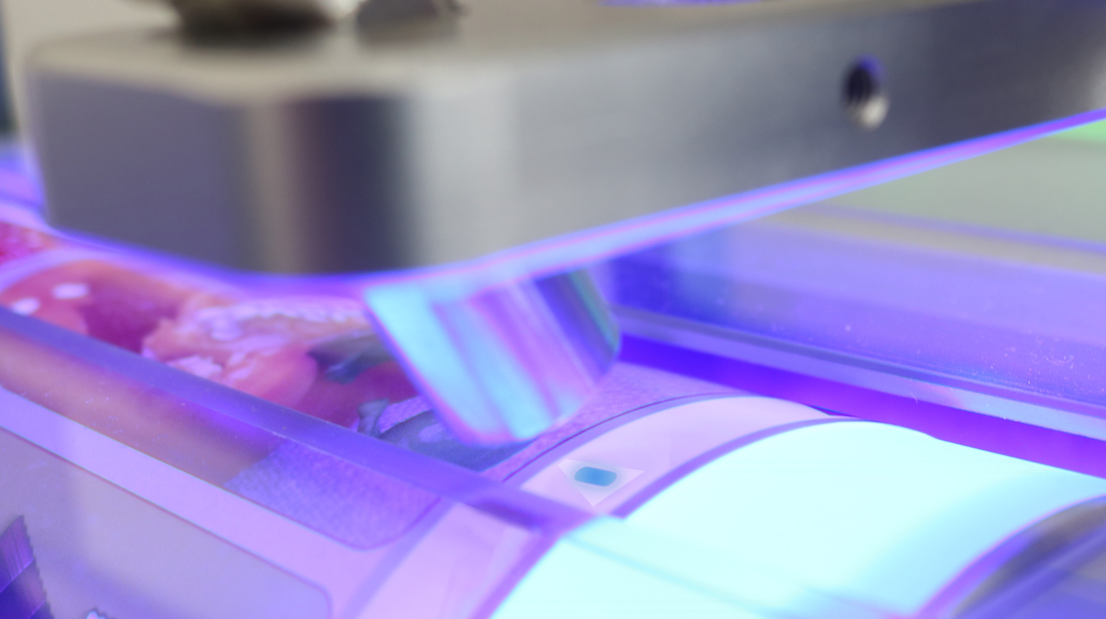
Image 2: The new RSH-UV sensor can be used to quickly and reliably adjust the lateral and longitudinal register of UV coatings.

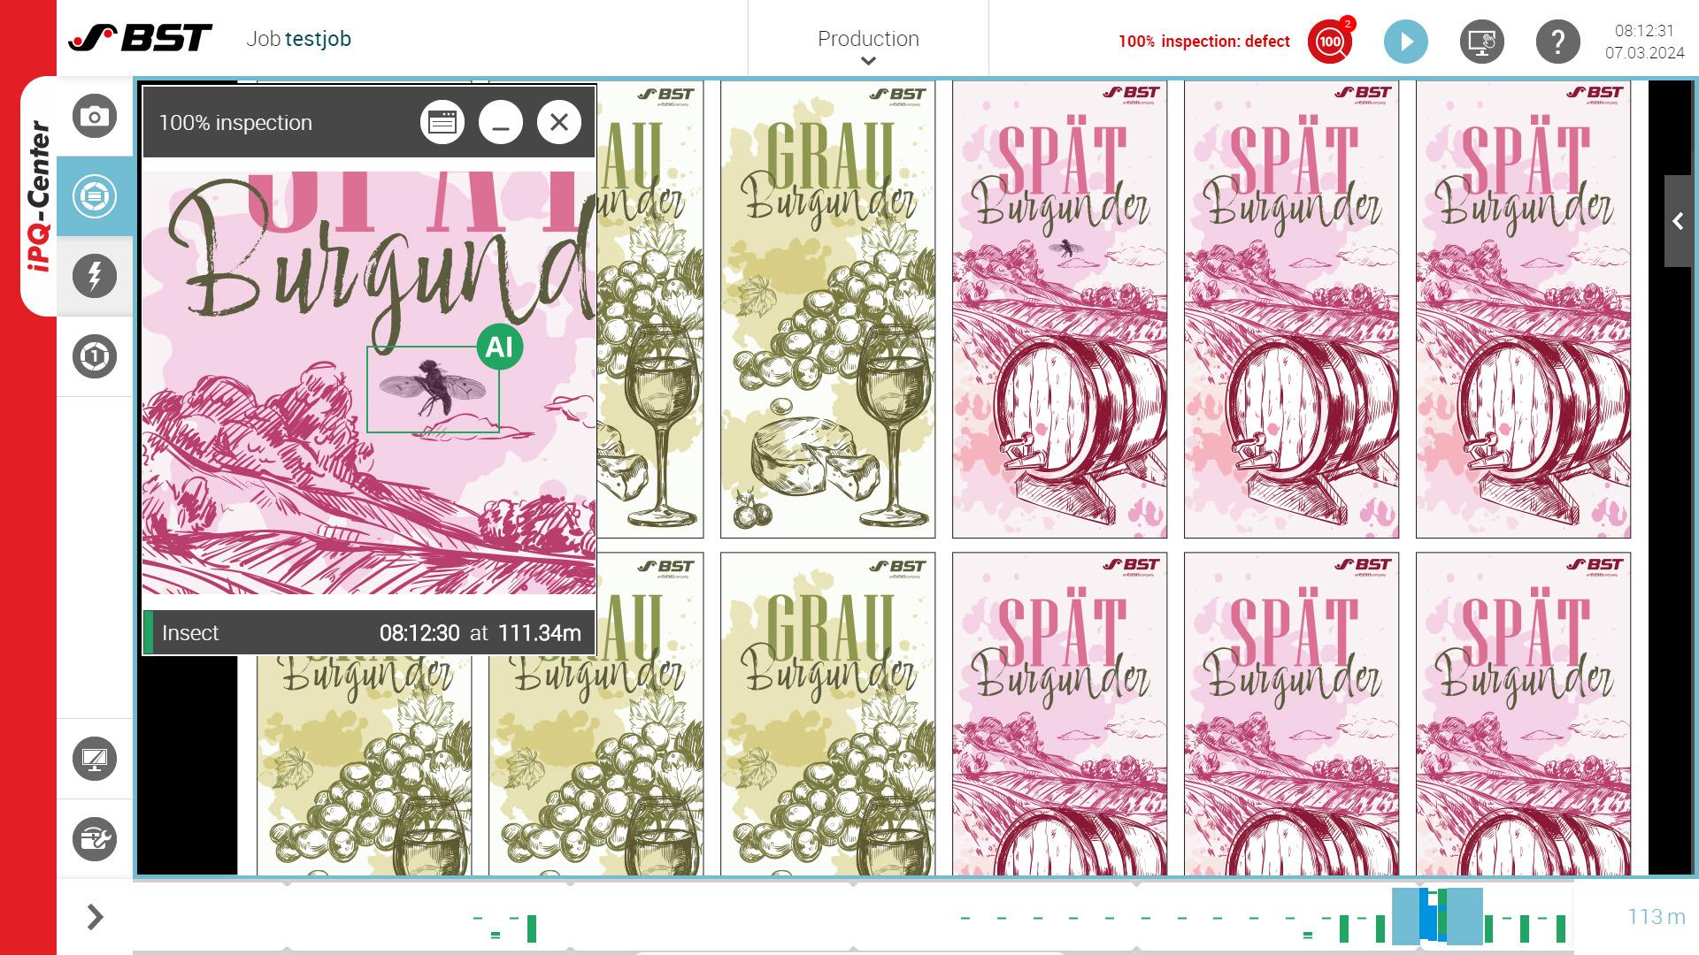
Image 3: For even more precise defect classification, both iPQ-Check and iPQ-Check Digital now offer an additional defect class whose data set is generated using artificial intelligence.

Pictures: BST GmbH

